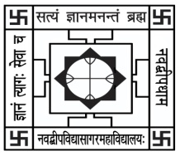NABADWIP VIDYASAGAR COLLEGE

Department of Botany

Internal Examination for Honours Course

**Semester- I Paper- UG-H-BOT-CC-T-01 Time: 15 Min.**

**Name:**  **Roll No.**

*Each question carries 2 marks (attempt any 5):* Marks: 5x2=10

Q1. What is cell wall?

Q2. Why plant cell is different from animal cell?

Q3. Mention two distinguishing characteristics of Eukaryotic cell.

Q4. What is cell cycle?

Q5. Name one simple amino acids?

Q6. Who proposed cell theory?

Q7. What do you mean by endomembrane?