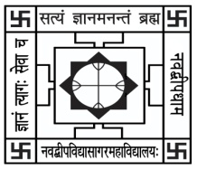NABADWIP VIDYASAGAR COLLEGE

Department of Botany

Internal Examination for Honours Course

**Semester- I Paper- UG-H-BOT-CC-T-02 Time: 15 Min.**

**Name:**  **Roll No.**

*Each question carries 2 marks (attempt any 5):* Marks: 5x2=10

Q1. What is continuous inflorescence?

Q2. Which inflorescence is terminated by a terminal flower?

Q3. Differentiate sepals from calyx.

Q4. What is corolla?

Q5. Name the modification of ovary after fertilization?

Q6. Flower is modified shoot, justify the statement.

Q7. What do you mean cymose inflorescence?