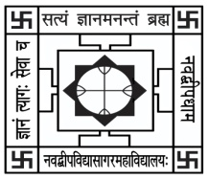NABADWIP VIDYASAGAR COLLEGE

Department of Botany

Internal Examination for Honours Course

**Semester- IV Paper- UG-H-BOT-CC-T-09 Time: 20 Min.**

**Name:**  **Roll No.**

*Each question carries 2 marks (attempt any 5):* Marks: 5x2=10

Q1. What is ecological efficiency?

Q2. What are biogeochemical cycles?

Q3. Write down the basic levels of a trophic organization

Q4. What is the difference between production and productivity?

Q5. Write down an example of an inverted ecological pyramid in nature.

Q6. Write down an example from each of gaseous and sedimentary cycles?