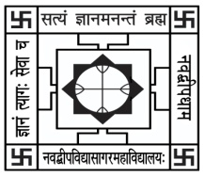NABADWIP VIDYASAGAR COLLEGE

Department of Botany

Internal Examination for Honours Course

**Semester- IV Paper- UG-H-BOT-CC-T-10 Time: 20 Min.**

**Name:**  **Roll No.**

*Each question carries 2 marks (attempt any 5):* Marks: 5x2=10

Q1. What is crop domestication?

Q2. What are the uses of Para-rubber?

Q3. Classify fibers based on their source/origin.

Q4. Name two crude drugs available in the market?

Q5. What do you understand by adulterant in herbal medicine?

Q6. How does leaves morphology of legumes differ than the grasses?