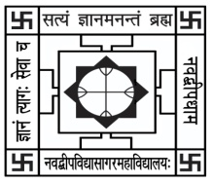NABADWIP VIDYASAGAR COLLEGE

Department of Botany

Internal Examination for Honours Course

**Semester- V Paper- UG-H-BOT-DSE-T-2 Time: 15 Min.**

**Name:**  **Roll No.**

*Each question carries 2 marks (attempt any 5):* Marks: 5x2=10

Q1. What is chi square?

Q2. Write the role of chi-square in biometry.

Q3. What is cross fertilization?

Q4. What is the difference between mass selection and pure line selection?

Q5. What is QTL?

Q6. What are the different types of QTL you have studied in your syllabus?

Q7. In an experiment, (3:1 ratio maintained) the observed value is 32 and 68. Calculate the chi-square value ?