Seminar/Webinar Report Template
Title of the Webinar: | A NATIONAL LEVEL WEBNAR ON CHANGING SCENARIO AND ESSENTIALITIES IN HIGHER EDUCATION IN THE NEO-NORMAL AGE.
Sub topic (if any) | Student support system in the Higher Educational Institutions | Theme-Changing Identities in Higher Education
Date & Time: | 26-07-2020 AT 2.00 PM | 26-07-2020 AT 2.00 PM
Speaker Details: | DR. SHNAOLI CHAKRABORTY ACHARYA  M. A. (English), M. Ed., Ph. D. (Education)  Assistant Professor  Department of Education  West Bengal State University,  Barasat, Kolkata- 700126,West Bengal.  Connect : shnaolic@gmail.com / 9163840705 | DR. SAMBIT KUMAR PADHI  Assistant Professor  Department of Education  Guru Ghasidas Central University  Bilaspur, Chhattisgarh  Theme-Changing Identities in Higher Education
YouTube link: | https://youtu.be/zKM8ZghYYwE | https://youtu.be/zKM8ZghYYwE

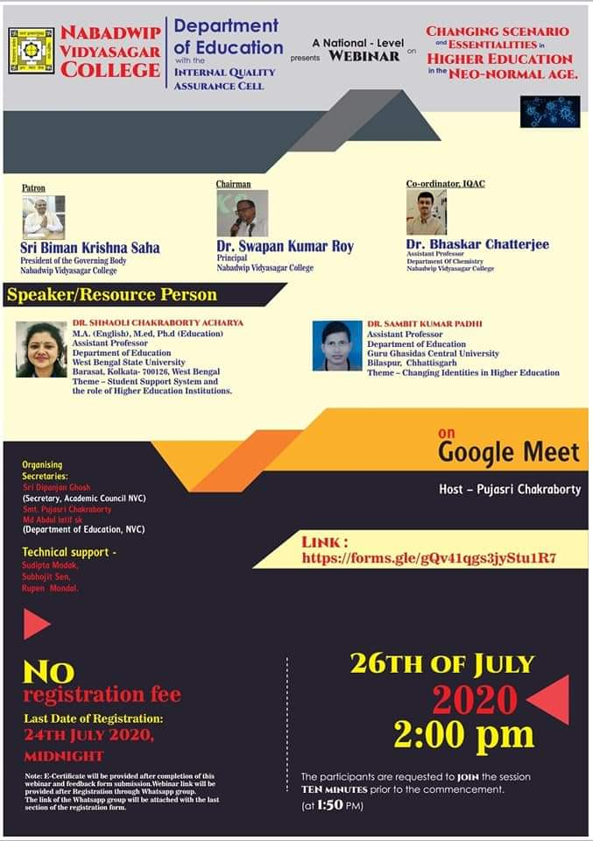 | Please insert or paste Photo/Screen Shot of the seminar or webinar within this box.

Very concise content of the report:
A Webinar on the topic A NATIONAL LEVEL WEBNAR ON CHANGING SCENARIO AND ESSENTIALITIES IN HIGHER EDUCATION IN THE NEO-NORMAL AGE.was organized by Department of education with the Internal Quality Assurance Cell(IQAC)of DR. SHNAOLI CHAKRABORTY ACHARYAAssistant ProfessorM.A (English), M. Ed., Ph. D. (Education)Department of Education ,West Bengal State University,Barasat, Kolkata- 700126,West Bengal.And DR. SAMBIT KUMAR PADHI Assistant Professor Department of Education Guru Ghasidas Central University Bilaspur, Chhattisgarh.On 26 th July 2020 at 2.00 PM. The present crisis situation has placed the students fraternity before an unique dilemma about their feature study and career. It also important to remember that all of us can experience poor mental health and wellbeing at some point in our lives. Student support service foster positive relationship among educators and students. After that questions and interaction session was held in teachers also shared the information. Almost 333 people attended the webinar.

