**Nabadwip Vidyasagar College**

**Department of Environmental Science**

* **Wall Magazine 2018, Topic: Kerala Flood,2018**

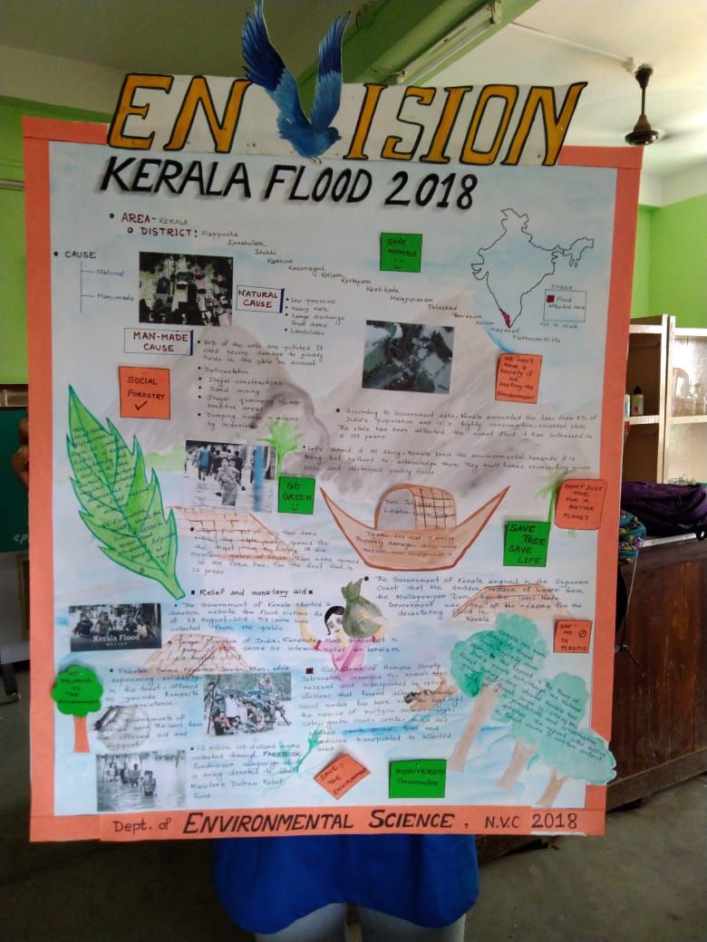

* **Wall Magazine 2019, Topic: The Amazon is burning,2019**

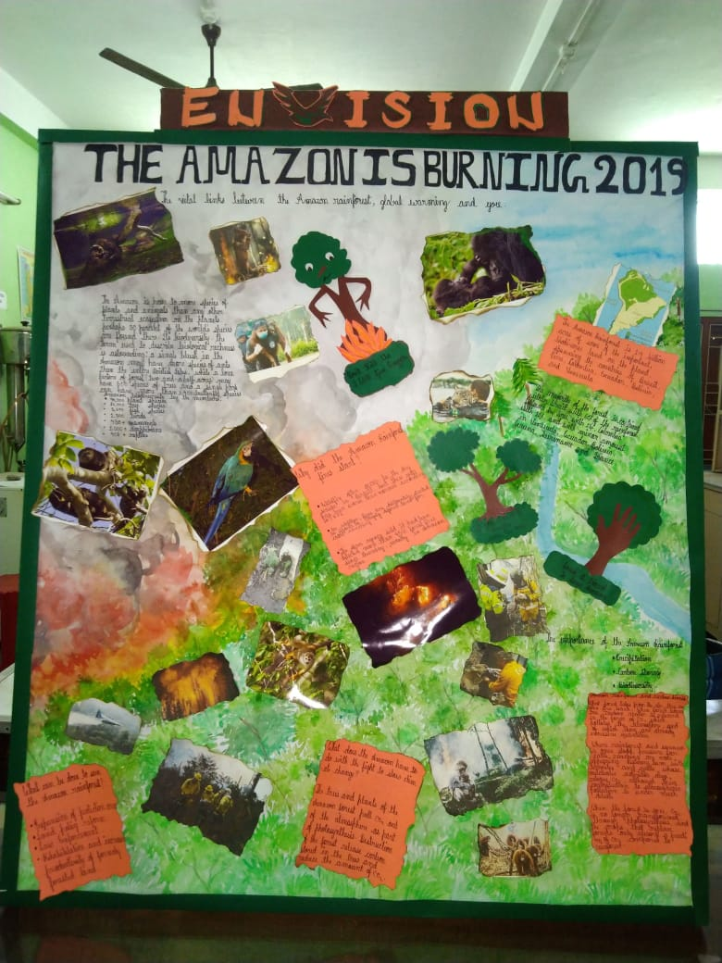

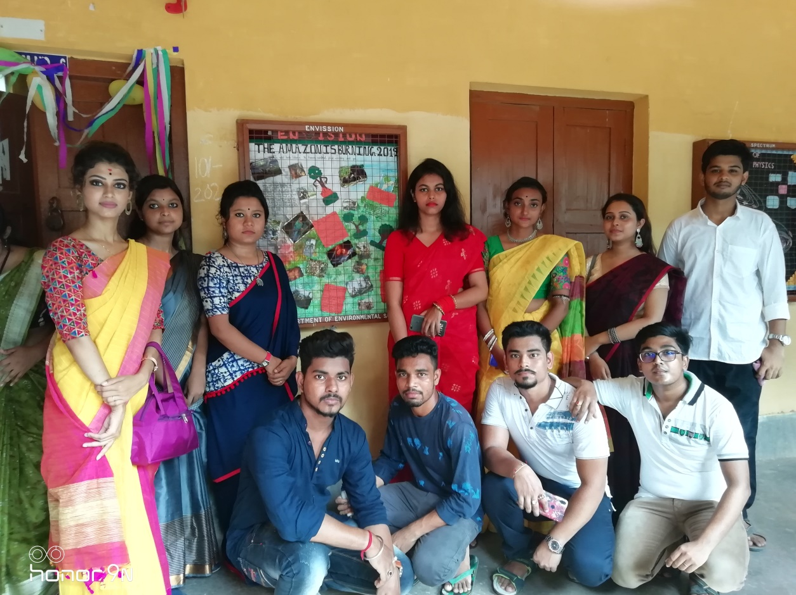

* **Wall Magazine 2021- 22, Topic: Invest in our planet**



