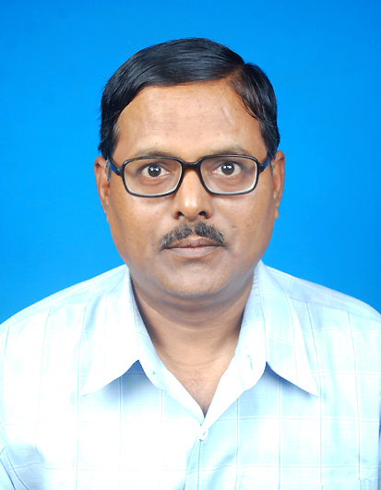
Name: DR. PRAVASH MANDAL
Designation: ASSOCIATE PROFESSOR AND HEAD
Department: PHYSICS
Date of Joining: 21.09.2001
Address: VILL.BEJPARA, P.O. DIGHRA, P.S. CHAKDAHA, DIST. NADIA,
PIN:741222, WEST BENGAL, INDIA.
Phone No.: (0)9474497030
E-mail: pravash@nvc.ac.in , pmandalnvc@gmail.com
Academic Qualification: Ph.D.
Specialization in Master Degree: ELECTRONICS
Courses Taught: B.Sc. (HONS.) CLASSES OF 1ST, 2ND AND 3RD YEAR (THEORY AND PRACTICAL);
GENERAL CLASSES ( BOTH THEORY AND PRACTICAL).

Convener/In-charge of Committees/Sub-Committees: NOT TILL NOW

Member of Committees/Sub-Committees: Member of Academic, Wall Magazine, Vidyasagar Anniversary, Games & Sports, Service Book & Leave, Promotion & Fixation, Faculty & Staff welfare Sub-committees.

Research Interest (in brief): I carried out research in the field of Anti-ferroelectric Liquid Crystals for PhD thesis in the Department of Physics, University of Kalyani, Nadia, West Bengal, India.

.

CURRENT RESEARCH INTEREST: Liquid Crystals, OPTICAL ELECTRONICS, CONDENSED MATTER PHYSICS ETC.
Publications (enclose separate sheet if needed):
- An overview on the Anisotropic Properties of Liquid Crystals, Dr. Pravash Mandal, International Journal of Current Advanced Research, Vol. 8, Issue 10(d),, pp. 20313-20316, October 2019.
- Theoretical Behaviour about the Freedricksz Transition in Polymer Dispersed antiferroelectric Liquid Crystals, Pravash Mandal, Deblal Das and Tapas Pal Majumder, International Journal of Current Advanced Research, Vol. 7, Issue 1(J), pp. 9402-9406, January 2018.

- The effect of Spin-Spin Interaction in the region of Freedricksz Transition in antiferroelectric Liquid Crystals, Tapas Pal Majumder, Pravash Mandal and Deblal Das, Journal of Pure Applied and Industrial Physics, Vol. 7(12), pp. 436-443, December 2017.
- The Effect of Ferrroelectric Polarisation within the range of Freedericksz Transition, D Das, P Mandal, T P Majumder, Journal of Pure, Applied & Industrial Physics, 2017,vol 7 (5), 175-183, May 2017.
- Theoretical investigation of dielectric behaviour in the region of Freedericksz transition in antiferroelectric liquid crystals, Pravash Mandal, Deblal Das, Tapas Pal Majumder, Journal of Molecular Liquids, 2016, vol. 215, pp. 170-174.
- Applications of Boolean Algebra in Digital Electronics: An Overview‖, P. Mandal, Edulight, 4, 7, 223-230, (2015), ISSN- 2278-9545.
- Basic Concepts of Fiber-optic Communication, P. Mandal, Contemporary Research in India, 5, 2, 1-5 (2015), ISSN-2231-2137.
- Fundamentals of Liquid Crystals and Applications: an Overview‖, P. Mandal, Contemporary Research in India, 5, 3, 1-7 (2015), ISSN-2231-2137.
- Introduction to Superconductivity and High Tc Super conductors‖, P. Mandal, Contemporary Research Spectrum, 1, 1, 85-92, (2015) ISSN-2454-8987
- Dielectric Behavior of Antiferroelectric Liquid Crystals in presence of Flexoelectric Effect, D Das, P Mandal, T P Majumder, Brazilian Journal of Physics, 2015, vol 45, no 3, 280-287, ISSN – 0103-9733
- The effect of spin-spin interaction on the complex dielectric permitivity in antiferroelectric liquid crystals, D Das, P Mandal, T P Majumder, Sci.Lett. 2015, 4: 194,1-5.
Ongoing and Completed Research Projects (enclose separate sheet if needed): NONE.

Books/Reports/General Articles/Chapters (enclose separate sheet if needed): NONE.

Talks/Posters/Papers Presented (enclose separate sheet if needed): None

Participation in Schools/Conferences/Workshops/Symposia/Seminars:
(enclose separate sheet if needed)
National Level
- UGC sponsored national-level seminar on Application of Mathematics in Science and Social Science, organised by the Department of Mathematics, Nabadwip Vidyasagar College on 10th and 11th January 2012.
- UGC sponsored national-level seminar on Impact of Environmental Education on Daily Life organised by Shimurali Sachinandan College of Education, Nadia on 16th July 2013.
- National Conference on Current Trends in Particle Physics Research organized by Department of Physics, University of Kalyani on March 13 -15, 2014.
- UGC sponsored national-level seminar on Development and the Role of Local Self- Government: Indian Perspective, Organized by the Department of Commerce and the Department of Economics, Nabadwip Vidyasagar College, Nadia on December 11 &12, 2015.
State Level
- State Level Seminar on Trends in Astronomy, Astrophysics and Cosmology, organized by Department of Physics Kalna College, Burdwan on 21-22 November, 2011.
- UGC sponsored State-level seminar on Bio-diversity in India: Perspective, Management and Conservation, organized by Dwijendralal College, Nadia on 26th February 2011.
- UGC sponsored Course-work on Research Methodology, organized by Nabadwip Vidyasagar College on & from 27-30, March, 2012.
- Professor Satya Sundar Barman Memorial Lecture-2016 on Scientific Development and Technological Innovation of the 21st Century- Paving Peace or Annihilation, organized by Krishnagar Government College on 10th December 2016.
Awards/Prizes/Certificates (enclose separate sheet if needed):

S. No. | Name of award | Awarding Agency | Year
1 | West Bengal State Level Eligibility Test | WBCSC | 1996

Member of State/National/International Professional Bodies: Life Member of IACS& IAPT

Personal Webpage: (Link if any)
Research Gate Profile: NIL

